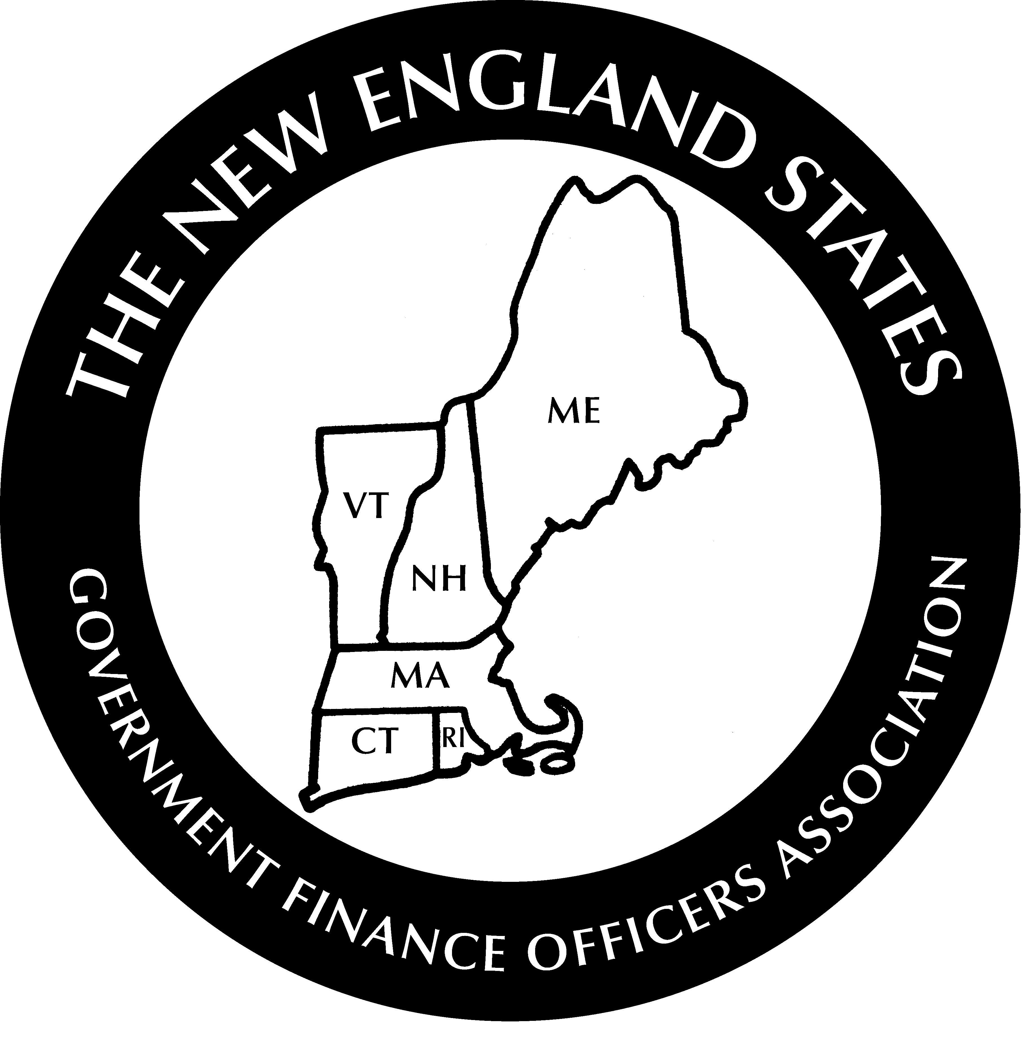

NEW ENGLAND STATES GOVERNMENT
FINANCE OFFICERS ASSOCIATION
www.nesgfoa.org

DONALD J. MIKLUS 31ST ANNUAL
SPRING TRAINING SEMINAR
The Conference Center at Waltham Woods
April 17-18, 2024

Wednesday, April 17

9:00 – 10:00 AM Registration

10:00 AM WELCOME: Lisa Hancock, NESGFOA President

10:00 – 11:00 AM Update on Tax-Exempt Bonds Arbitrage Rules
Mike Scarfo, AMTEC

11:00 - 12:00 AM Economic Overview and Update
James Marple, TD Bank

12:00 – 1:15 PM LUNCHEON

1:15 – 2:15 PM Annual Continuing Disclosures related to Tax-Exempt Bonds
Alexander Shih, Raymond James
Matthew Page, Mintz, Levin, Cohn, Ferris, Glovsky, and Poper, P.C.

2:15 – 2:30 Break
2:30 – 3:30 PM Ethics
Steve Gross, CliftonLarsonAllen, LLP
Dave Hansen, CliftonLarsonAllen, LLP

Thursday, April 18, 2024

8:30 AM Registration and Continental Breakfast

9:00 – 10:00 AM Artificial Intelligence in Government
Mitch Thompson, CLA Connect

10:00 – 10:15 Break

10:15 – 11:15 AM Update on ARPA
James Powers, Marcum LLP

11:15 – 12:15 PM Bringing Balance and Productivity to the Workplace
Trish Hart, HartMindBody Solutions
Sponsored by the Massachusetts Municipal Employees Health Trust

12:15 – 1:15 PM Luncheon

1:15 – 2:15PM Improving your MD&A

Safe Travels Home

Save the Date

77th Annual Fall Conference

September 15-18, 2024

Hilton Mystic

Mystic, Connecticut

